Problem 1

c)

Time series plot

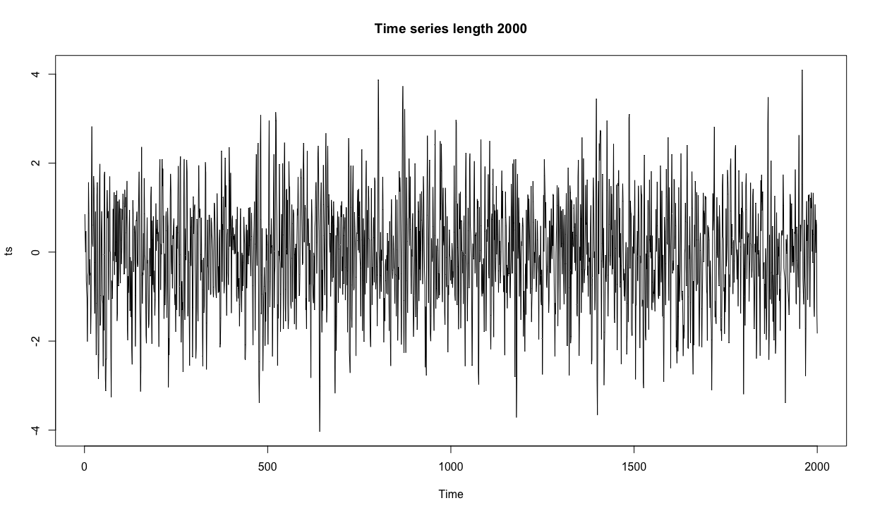

Autocorrelation plot



Lag values:

Lag-1: 0.442

Lag-2: -0.098

Lag-3: -0.225

d)

Partial autocorrelation plot



Lag values:

Lag-1: 0.442

Lag-2: -0.364

Lag-3: -0.008

Problem 3

a)





b)



c)

decompose()



stl()



Problem 4

a)

log likelihood = -446.1314

b)

log likelihood = -446.9549

c)

MLE 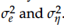

0.287369728 | 0.009473803

d)







e)

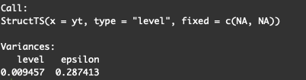

Comparing the variance estimates with the ones from part c), they are practically the same, the difference is minimal.